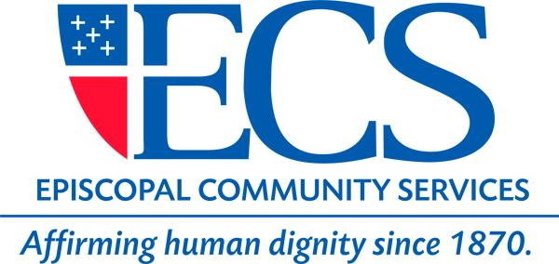

Assistant Director, Out of School Time Programs

The newly expanded ECS Out of School Time department (OST), a Philadelphia school-based community services program is seeking to fill its’ Assistant Director (AD) of OST Programs opening.

The Assistant Director will report to the Director of OST Programs and will oversee the management of five OST sites in schools located in Olney/Feltonville and West Philadelphia. The AD will also serve as liaison to the Feltonville Educational Campus administration, faculty, and the Children’s Investment Strategy of the City of Philadelphia.

The ideal candidate will possess the ability to relate to culturally diverse children, youth, and adults in a variety of settings in a helpful and non-judgmental manner. This position requires knowledge of Theory of Change processes, as well as, demonstrated supervisory and administrative skills.

Duties
- Oversee and supervise leadership staff of all DHS ECS OST Programs.
- Program development at the ECS OST Programs.
- Represent ECS at meetings of Pennsylvania Department of Human Services, Public Health Management Corporation (PHMC), United Way, and other meetings as deemed necessary.
- Represent ECS at neighborhood and Philadelphia School District meetings as required.
- Ensure compliance with all contractual and grant requirements at the DHS ECS OST Programs.
- Maintain compliance with all license requirements at DHS ECS OST Programs.
- Ensure client data is entered into the database in a timely manner and that reports are generated as needed for funding or tracking purposes.
- Monitor and evaluate DHS ECS OST Programs and report regularly to the Director and to the Program Committee as requested.
- Assist and track and be knowledgeable regarding public policy and advocacy activities in the areas of Out of School Time Programs Educational Initiatives and represent ECS at public policy and advocacy collaborations as agreed.
- Prepare quarterly program reports.
- Develop and maintain relationships with all appropriate groups, agencies, and organizations, and any and all other child advocacy agencies and community service organizations.
- Write and revise, as necessary, the job descriptions for all staff for necessary staff within the ECS OST Programs.
- Prepare quarterly performance evaluations (oral and written) for all administrative and management Out of School Time Programs staff.
- Manage day-to-day fiscal operations.
- Submit monthly and quarterly reports to grantors (as required).
- Review and approve all monthly and quarterly reports and documentation to substantiate those reports.
- Submit expenditures to the Finance Department for reimbursement and accounting.
- Assist Director in developing department annual budget with Finance Department.
- Attend and participate in leadership meetings and activities.

Qualifications

- Master’s degree or equivalent in a relevant discipline.
- 3 years’ experience relevant to job duties and responsibilities.
- Excellent written and oral communication skills.
- Proven supervisory and administrative skills.
- Ability to work with neighborhood organizations and diverse communities.
- Ability to represent ECS in a variety of settings
- Knowledgeable of Theory of Change Processes
- Able to implement strategy to facilitate growth amongst programs and cultivate leadership amongst staff.

We offer a very competitive salary and excellent benefits package; medical/dental, 401(k), short/long term disability, transportation subsidy, tuition reimbursement, student loan forgiveness, adoption assistance, first time home owner assistance and generous vacation allotment. Forward your resume and cover letter to ECS, 225 S. 3rd Street, Philadelphia PA 19106; or email hr@ecs1870.org.

For a more comprehensive overview of our benefits package or to apply online please return to our employment home page; at www.ecsphilly.org/about-ecs/employment EOE

